From: http://www.aljazeera.com/news/middleeast/2013/06/20136104317486359.html on 2013001.

Mass Palestinian grave found in Tel Aviv
Skeletal remains of dozens of Palestinians killed by Israelis during 1948 have been found in a mass grave in Tel Aviv.
Last Modified: 01 Jun 2013 01:01
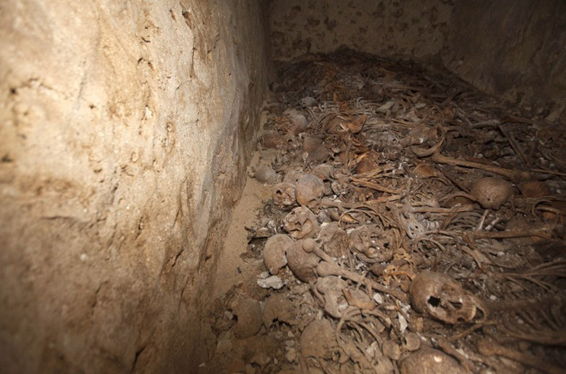
At least six chambers filled with the skeletal remains of Palestinians were found in the Jaffa district of Tel Aviv [AFP]
The remains of dozens of Palestinians killed by Israelis in fighting during the war of 1948 which led to the creation of the state of Israel have been found in a mass grave in Tel Aviv's Jaffa district.
An official at the Muslim cemetery there told AFP news agency that the grisly find occurred on Wednesday when ground subsided as workers carried out renovations, revealing six chambers full of skeletons.
Jaffa fisherman Atar Zeinab, 80, says that as a teenager during the final months of fighting in 1948, he helped to collect the Arab dead in the area south of Jaffa and bring them for hasty burial in the cemetery, the area's main graveyard.
"I carried to the cemetery 60 bodies during a period of three or four months," he told AFP. "We used to find the people in the street and most of the time we didn't know who they were."
He said that the danger of being hit by flying bullets or grenade fragments was such that bodies were dumped one on top of the other in existing family crypts in the cemetery, contrary to Muslim custom.
"We carried them early in the morning or in the night," he added. "We put women, children and men in the same place...nobody prayed for these people."
Jaffa was at the time a Palestinian town, but there was a forced exodus of most of its Arab population when it fell to the fledgling Israeli army and rightwing Jewish armed gangs.
In 1950 it was incorporated into the city of Tel Aviv which was renamed Tel Aviv-Jaffa.
Today it has a mixed Arab and Jewish population.
Around 760,000 Palestinians fled or were forced from their homes in what they call the "Nakba" or "catastrophe" of 1948.

